1. Remote Simple Calculator – The server was created using the Server Socket Class in Java.

***Server.java***

import java.io.IOException;  
import java.net.ServerSocket;  
import java.net.Socket;   
import java.util.Scanner;  
import java.lang.*;  
import java.io.*;   
  
public class Server{  
 public static void main(String[] args){  
 try{  
 ServerSocket serverSocket = new ServerSocket(4444);  
 System.out.println("Server Started...");  
 while(true){  
 new Thread(new ClientConnectionThread(serverSocket.accept())).start();  
 }  
   
 }catch(IOException e) {e.printStackTrace();}  
   
 }  
  
}  
class ClientConnectionThread implements Runnable{  
 private Socket socket;  
 public ClientConnectionThread(Socket socket){  
 this.socket = socket;  
 }  
 @Override  
 public void run(){  
 try{  
 DataInputStream dIn = new DataInputStream(socket.getInputStream());  
 DataOutputStream dOut = new DataOutputStream(socket.getOutputStream());  
 String message = dIn.readUTF();  
  
 System.out.println("Client Request : " + message);  
 String[] input = message.split(" ");   
 String result = input[0] + " " + input[2] + " " + input[1] + " = " + calculate(Integer.parseInt(input[0]), Integer.parseInt(input[1]), input[2]);  
 System.out.println("Server Response : " + result);  
  
 dOut.writeUTF(result);  
 dOut.flush();  
 dOut.close();  
 socket.close();  
 }catch(IOException e) {e.printStackTrace();}  
 }  
  
 public static String calculate (int num1, int num2, String operator) {  
 Integer result = 0;   
 switch (operator.charAt(0)){  
 case '+':  
 result = num1 + num2;  
 break;  
 case '-':  
 result = num1 - num2;  
 break;   
 case '*':  
 result = num1 * num2;  
 break;   
 case '/':  
 result = num1 / num2;  
 break;  
 }  
 return Integer.toString(result);  
   
 }  
}

***Android Client App: We had to make changes to the Manifest File 🡪 AndroidManifest.xml***

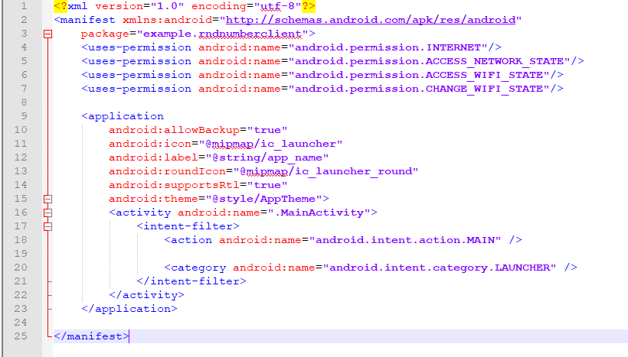

***MainActivity.java***

package example.rndnumberclient;  
  
import android.support.v7.app.AppCompatActivity;  
import android.os.Bundle;  
import android.text.TextUtils;  
import android.view.View;  
import android.widget.EditText;  
import android.widget.Button;  
import android.widget.TextView;  
import java.io.IOException;  
import java.net.Socket;  
import java.io.*;  
import java.net.UnknownHostException;  
import java.lang.*;  
  
public class MainActivity extends AppCompatActivity implements View.OnClickListener {  
  
 EditText n;  
 EditText max;  
 EditText min;  
 TextView displayResult;  
 Button submit;  
 MainActivity activity;  
 Socket socket;  
 String response = "";  
  
 */** Called when first created. */* @Override  
 public void onCreate(Bundle savedInstanceState) {  
 super.onCreate(savedInstanceState);  
 setContentView(R.layout.activity_main);  
  
 // find the EditText elements (defined in res/layout/activity_main.xml  
  
 n = (EditText) findViewById(R.id.editText);  
 min = (EditText) findViewById(R.id.editText2);  
 max = (EditText) findViewById(R.id.editText3);  
 submit = (Button) findViewById(R.id.button);  
 displayResult = (TextView) findViewById(R.id.displayResult);  
 // set listeners  
 submit.setOnClickListener(this);  
 }  
 // @Override  
 public void onClick( View view ) {  
 // check if the fields are empty  
 if (TextUtils.isEmpty(n.getText().toString())  
 || TextUtils.isEmpty(min.getText().toString()) ||  
 TextUtils.isEmpty(max.getText().toString())) {  
 return;  
 }  
 new Thread(new Runnable() {  
 @Override  
 public void run() {  
 try {  
 response = "";  
 socket = new Socket("10.0.2.2", 4455);  
 DataOutputStream dOut = new  
 DataOutputStream(socket.getOutputStream());  
 DataInputStream dIn = new  
 DataInputStream(socket.getInputStream());  
 dOut.writeUTF(n.getText() + " " + min.getText() +  
 " " + max.getText());  
 dOut.flush();  
 response = dIn.readUTF();  
 runOnUiThread(new Runnable() {  
 @Override  
 public void run() {  
 displayResult.setText(response);  
 }  
 });  
 dIn.close();  
 dOut.close();  
 socket.close();  
 }  
 catch (UnknownHostException e) {  
 e.printStackTrace();  
 displayResult.setText("UnknownHostException: " + e.toString());  
 } catch (IOException e) {  
 e.printStackTrace();  
 displayResult.setText("IOException: " + e.toString());  
 }  
 }  
 }).start();  
 }  
  
}

***Activity_Main.xml***

<?xml version="1.0" encoding="utf-8"?>  
<LinearLayout  
 xmlns:android="http://schemas.android.com/apk/res/android"  
 android:orientation="vertical"  
 android:layout_width="fill_parent"  
 android:layout_height="fill_parent">  
<LinearLayout  
 android:layout_width="match_parent"  
 android:layout_height="match_parent"  
 android:orientation="vertical">  
<EditText  
 android:id="@+id/editText"  
 android:layout_width="match_parent"  
 android:layout_height="wrap_content"  
 android:layout_weight="0.99"  
 android:ems="10"  
 android:inputType="textPersonName"  
 android:text="Enter Number" />  
<EditText  
 android:id="@+id/editText2"  
 android:layout_width="match_parent"  
 android:layout_height="wrap_content"  
 android:layout_weight="1"  
 android:ems="10"  
 android:inputType="textPersonName"  
 android:text="LowerBound" />  
<EditText  
 android:id="@+id/editText3"  
 android:layout_width="match_parent"  
 android:layout_height="wrap_content"  
 android:layout_weight="1"  
 android:ems="10"  
 android:inputType="textPersonName"  
 android:text="UpperBound" />  
<Button  
 android:id="@+id/button"  
 android:layout_width="match_parent"  
 android:layout_height="46dp"  
 android:layout_weight="1"  
 android:backgroundTint="@android:color/holo_blue_dark"  
 android:text="Submit" />  
<TextView  
 android:id="@+id/displayResult"  
  
 android:layout_width="match_parent"  
 android:layout_height="116dp"  
 android:layout_weight="1"  
 android:text="TextView" />  
</LinearLayout>  
</LinearLayout>

***Output:*** 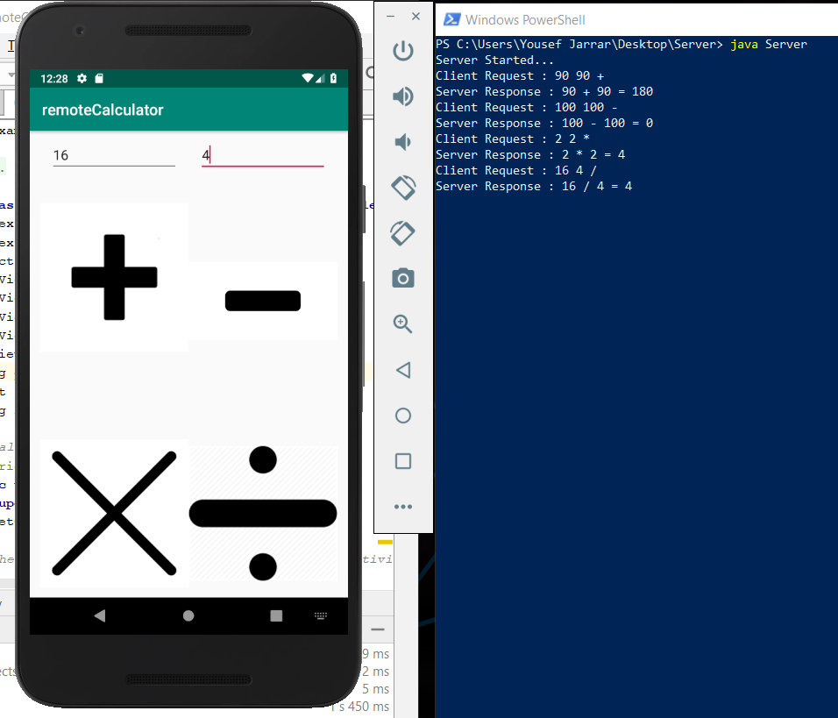

1. **Remote Random Number Generator**

**RandomNumberServer.java**

import java.io.IOException;  
import java.net.ServerSocket;  
import java.net.Socket;  
import java.util.Scanner;  
import java.lang.*;  
import java.io.*;  
import java.util.Random;  
import java.util.Arrays;  
  
public class RandomNumberServer {  
 public static void main(String[] args) {  
 try{  
 ServerSocket serverSocket = new ServerSocket(4455);  
 System.out.println("Server Started...");  
 while(true){  
 new Thread(new ClientConnection(serverSocket.accept())).start();  
 }  
 }catch(IOException e){e.printStackTrace();}  
 }  
}  
class ClientConnection implements Runnable{  
 private Socket socket;  
 public ClientConnection(Socket socket){  
 this.socket = socket;  
 }  
 @Override  
 public void run(){  
 try{  
 DataInputStream dIn = new DataInputStream(socket.getInputStream());  
 DataOutputStream dOut = new DataOutputStream(socket.getOutputStream());  
 String message = dIn.readUTF();  
 System.out.println("Client Request : " + message);  
 String[] input = message.split(" ");  
 String result = generateRandom(Integer.parseInt(input[0]),Integer.parseInt(input[1]), Integer.parseInt(input[2]));  
 System.out.println("Server Response : " + result);  
 dOut.writeUTF(result);  
 dOut.flush();  
 dOut.close();  
 socket.close();  
 }catch(IOException e){e.printStackTrace();}  
 }  
 public static String generateRandom(int num, int min, int max ) {  
 int range = (max - min) + 1;  
 String response ="";  
 for(int i=0;i<num;i++) {  
 response += Integer.toString((int)(Math.random() * range) + min) + " ";  
 }  
 return response;  
 }  
}

**Client:**

**package** example.rndnumberclient;  
  
**import** android.support.v7.app.AppCompatActivity;  
**import** android.os.Bundle;  
**import** android.text.TextUtils;  
**import** android.view.View;  
**import** android.widget.EditText;  
**import** android.widget.Button;  
**import** android.widget.TextView;  
**import** java.io.IOException;  
**import** java.net.Socket;  
**import** java.io.*;  
**import** java.net.UnknownHostException;  
**import** java.lang.*;  
  
**public class** MainActivity **extends** AppCompatActivity **implements** View.OnClickListener {  
  
 EditText **n**;  
 EditText **max**;  
 EditText **min**;  
 TextView **displayResult**;  
 Button **submit**;  
 MainActivity **activity**;  
 Socket **socket**;  
 String **response** = **""**;  
  
 */** Called when first created. */* @Override  
 **public void** onCreate(Bundle savedInstanceState) {  
 **super**.onCreate(savedInstanceState);  
 setContentView(R.layout.***activity_main***);  
  
 *// find the EditText elements (defined in res/layout/activity_main.xml* **n** = (EditText) findViewById(R.id.***editText***);  
 **min** = (EditText) findViewById(R.id.***editText2***);  
 **max** = (EditText) findViewById(R.id.***editText3***);  
 **submit** = (Button) findViewById(R.id.***button***);  
 **displayResult** = (TextView) findViewById(R.id.***displayResult***);  
 *// set listeners* **submit**.setOnClickListener(**this**);  
 }  
 *// @Override* **public void** onClick( View view ) {  
 *// check if the fields are empty* **if** (TextUtils.*isEmpty*(**n**.getText().toString())  
 || TextUtils.*isEmpty*(**min**.getText().toString()) ||  
 TextUtils.*isEmpty*(**max**.getText().toString())) {  
 **return**;  
 }  
 **new** Thread(**new** Runnable() {  
 @Override  
 **public void** run() {  
 **try** {  
 **response** = **""**;  
 **socket** = **new** Socket(**"10.0.2.2"**, 4455);  
 DataOutputStream dOut = **new** DataOutputStream(**socket**.getOutputStream());  
 DataInputStream dIn = **new** DataInputStream(**socket**.getInputStream());  
 dOut.writeUTF(**n**.getText() + **" "** + **min**.getText() +  
 **" "** + **max**.getText());  
 dOut.flush();  
 **response** = dIn.readUTF();  
 runOnUiThread(**new** Runnable() {  
 @Override  
 **public void** run() {  
 **displayResult**.setText(**response**);  
 }  
 });  
 dIn.close();  
 dOut.close();  
 **socket**.close();  
 }  
 **catch** (UnknownHostException e) {  
 e.printStackTrace();  
 **displayResult**.setText(**"UnknownHostException: "** + e.toString());  
 } **catch** (IOException e) {  
 e.printStackTrace();  
 **displayResult**.setText(**"IOException: "** + e.toString());  
 }  
 }  
 }).start();  
 }  
  
}

***UI.xml***

*<?***xml version="1.0" encoding="utf-8"***?>*<**LinearLayout  
 xmlns:android="http://schemas.android.com/apk/res/android"  
 android:orientation="vertical"  
 android:layout_width="fill_parent"  
 android:layout_height="fill_parent"**>  
 <**LinearLayout  
 android:layout_width="match_parent"  
 android:layout_height="match_parent"  
 android:orientation="vertical"**>  
 <**EditText  
 android:id="@+id/editText"  
 android:layout_width="match_parent"  
 android:layout_height="wrap_content"  
 android:layout_weight="0.99"  
 android:ems="10"  
 android:inputType="textPersonName"  
 android:text="Enter Number"** />  
 <**EditText  
 android:id="@+id/editText2"  
 android:layout_width="match_parent"  
 android:layout_height="wrap_content"  
 android:layout_weight="1"  
 android:ems="10"  
 android:inputType="textPersonName"  
 android:text="LowerBound"** />  
 <**EditText  
 android:id="@+id/editText3"  
 android:layout_width="match_parent"  
 android:layout_height="wrap_content"  
 android:layout_weight="1"  
 android:ems="10"  
 android:inputType="textPersonName"  
 android:text="UpperBound"** />  
 <**Button  
 android:id="@+id/button"  
 android:layout_width="match_parent"  
 android:layout_height="46dp"  
 android:layout_weight="1"  
 android:backgroundTint="@android:color/holo_blue_dark"  
 android:text="Submit"** />  
 <**TextView  
 android:id="@+id/displayResult"  
  
 android:layout_width="match_parent"  
 android:layout_height="116dp"  
 android:layout_weight="1"  
 android:text="TextView"** />  
 </**LinearLayout**>  
</**LinearLayout**>

